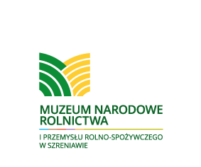

Dear Madam,

The National Museum of Agriculture and Food Industry in Szreniawa invites you to take part in the 7th edition of the International Conservation Conference “Problems connected with Keeping and Conservation of Collections in Museums”, which will take place on October 12-14, 2016. The Conference is co-organised by National Institute for Museums and Public Collections.
We wish to devote this meeting on cultural heritage safeguarding to the issues discussed within four panels:
- Protection of objects made from organic materials
- Conservation of large size objects and objects intended to be launched
- Conservation methods of museum objects and conservator’s duties in designing and modernization of exhibitions
- Organization and management of conservation in museums
We will commence the discussion of the issues above with papers concerning the solutions for protection of objects made from organic materials. We will discuss the issue of destructive power of time and influence of technical condition of storage and climate conditions on historic objects, as well as preventive conservation. Afterwards we shall deal with conservation of large size objects and those intended to be launched. We will discuss i.a. the theme of “living museum” and rules of launching historic objects. The third thematic block beside issues connected with traditional and innovative methods of conservation will be focused on conservator’s responsibility in designing and modernization museum exhibitions. The conference will be closed with papers on options for improving the effectiveness of conservation work by creating optimal conditions as regards organisation and management, as well as professional training and sharing the expertise.
On the second day, 13 October, is planned the study tour to Museum of Basketry and Hop Growing with the lecture of prof. Jędrzej Stępak from Adam Mickiewicz University titled “Living Basketry Forms”. Then we will visit the Centre of Folk and Nature Education in Mniszki.
Within the Conference is planned the publication of registered lectures and speeches and presentations of conservation means/materials/methods. Conference fee is 400 PLN (95 EUR)and it includes accommodation, meals and Conference kit ( programme and summaries of papers). With no accommodation the Conference fee is 250 PLN (60 EUR). The Conference will be followed by publication of the proceedings, and speakers will receive two copies of them each.
In order to register your participation, please fill and send in the enclosed form, which is also available from our website.
In the hope that this conference, just as its previous editions , will contribute to the integration of actions for the safeguarding of our common cultural heritage, we look forward to welcoming you to the Conference.

Kind regards,
The National Museum of Agriculture
and Food Industry in Szreniawa

