International Colloquium
“Animal Keeping and Traditional Plant Cultivation
in Museum Education”
National Museum of Agriculture and Food Industry
Szreniawa, Poland, 13-15 May 2016

The National Museum of Agriculture and Food Industry in Szreniawa invites you to the conference on “Animal Keeping and Traditional Plant Cultivation in Museum Education”, which will be held on 13, 14, 15 May 2016 in the conference hall of Szreniawa’s manor house. The main conference proceedings will be on 13 and 14 May and on 15 May, there is the Pentecost educational open–air shows with presentations of working farm animals in everyday life and historic rituals of a Polish village.
The conference is organized in cooperation with International Association of Agricultural Museums (AIMA), the National Heritage Board of Poland and the Association of Open Air Museums in Poland. The main goal of the conference is to create an international experience exchange forum and a basis for good museum practices.
Our main attention will focus on 7 thematic fields (shown below) in which papers and presentations will be delivered
- Farm Animal Keeping and Traditional Plant Cultivation in a Context of Agricultural and Related Museum’s Education Missions
- Shows of Animal Use and Plant Cultivation in Association with Phenology of Field Work Cadence as a Complement to Permanent Exhibitions
- Forms, Methods and Contents of Museum Education with the Use of Farm Animals and Cultivation in a context of Specific Audience Groups
- Animals and Agriculture in an Ethnographic Context (Customs and Rituals in Traditional Field Works)
- Popularization and Spreading of Domestic Breeds and Plant Varieties
- Museum Farm as a Pattern of Traditional Breeding Systems and Cultivation which can be useful for Modern Eco-Farms
- Farm Animal Behaviourism in a Context of Using Animals in Education

Dr. Jan Maćkowiak, Director, National Museum of Agriculture and Food Industry in Szreniawa

Contact person: Marianna Czerwińska, Adjunct Curator, Rural and Agricultural Heritage Research Department, National Museum of Agriculture and Food Industry in Szreniawa, E-mail: litoral.marianna@gmail.com Tel. +48 6181097 80

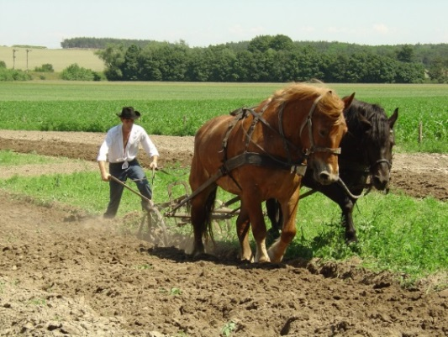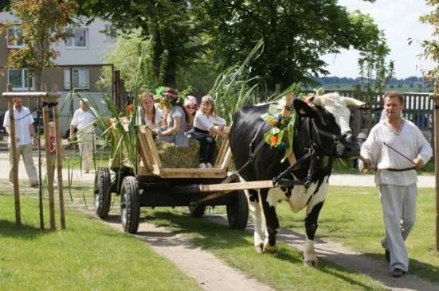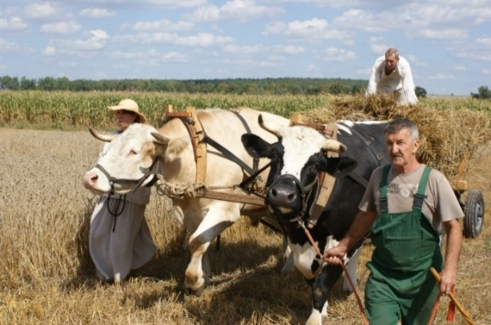
National Museum of Agriculture and Food Industry in Szreniawa
www.muzeum-szreniawa.pl

